“Social/Apartment Management System”
A Project Report Submitted in the partial fulfillment of the requirements for the award of the degree of

BACHELOR OF TECHNOLOGY
In
DEPARTMENT OF COMPUTER SCIENCE AND INFORMATION TECHNOLOGY
By

K.P.S. PRANAV 2520080031
K. CHAITANYA RAM 2520090106
K. BADARI NARAYANA 2520090165

Under the Esteemed Guidance of Divya Priya Degala Assistant Professor

Department of Computer Science and Information Technology




K L (Deemed to be) University

DEPARTMENT OF COMPUTER SCIENCE AND INFORMATION TECHNOLOGY

Declaration

The Project Report entitled “Social/Apartment Management System” is a record of bonafide work of K.P.S.PRANAV– 2520080031, K. CHAITANYA RAM – 2520090106, K. BADARI - 2520090165 submitted in partial fulfillment of the requirements of the course DATABASE SYSTEMS ENGINEERING AND DISTRIBUTED BACKEND DEVELOPMENT (25CS1302E), Section 10, Team 1, during 2026–2027, Trimester 4, at KLH University. The results embodied in this report have not been copied from any other student, department, or institution.

K.P.S. PRANAV– 2520080031
K. CHAITANYA RAM – 2520090106
K. BADARI - 2520090165

K L (Deemed to be) University

DEPARTMENT OF COMPUTER SCIENCE AND INFORMATION TECHNOLOGY

CERTIFICATE

This is to certify that the project report entitled “Event and Room Occupancy Management System” is a bonafide work done and submitted by K.P.S. PRANAV – 2520080031, K.CHAITANYA – 2520090106, K.BADARI - 2520090165 in partial fulfillment of the requirements of the course DATABASE SYSTEMS ENGINEERING AND DISTRIBUTED BACKEND DEVELOPMENT (25CS1302E), Section 10, Team 1, at KLH University
during 2026–2027, Trimester 4.

Signature of the Guide

Signature of the Course Coordinator Signature of the HOD

ACKNOWLEDGEMENT
The success in this project would not have been possible but for the timely help and guidance rendered by many people. Our wish to express my sincere thanks to all those who has assisted us in one way or the other for the completion of my project.

Our greatest appreciation to my Course Coordinator Dr , and my guide Divya Priya Degala, Department of Computer Science and Information Technology which cannot be expressed in words for his/her tremendous support, encouragement and guidance for this project.

We express our gratitude to Dr. Kaja Shareef, Head of the Department for Computer Science and Information Technology for providing us with adequate facilities, ways and means by which we are able to complete this project-based Lab.

We thank all the members of teaching and non-teaching staff members, and also who have assisted me directly or indirectly for successful completion of this project. Finally, I sincerely thank my parents, friends and classmates for their kind help and cooperation during my work.

K.P.S. PRANAV – 2520080031

K. CHAITANYA RAM – 2520090106

K. BADARI -2520090165

Abstract

The Social/Apartment Management System is a digital platform designed to simplify and automate the daily management activities of residential societies and apartment communities. The system provides a centralized platform where residents, administrators, security personnel, and maintenance staff can manage and access important information efficiently.
The system can be used to manage residents, apartments, maintenance payments, complaints, notices, visitor information, events, and other society-related activities. Instead of depending on registers, paper notices, phone calls, or manual records, the system stores information digitally and makes it easier to access, update, and maintain.
The main aim of this project is to improve communication, transparency, security, and efficiency within an apartment community. By reducing manual work and providing organized digital records, the system helps administrators manage the society more effectively while giving residents convenient access to important services and information.

Index
S.No. | Chapters | Topics | Page No.
 |  | Acknowledgement
 |  | Abstract
1 | Introduction | - Background of the Project  - Problem Statement  - Scope of the Project  - Objectives  - Importance of the Application  - Target Users / Audience | 5
2 | System Requirements | - Hardware Requirements  - Software Requirements  - Development Tools and Frameworks | 7
3 | Technology Stack | - Frontend  - Backend  - Database  - Version Control  - Authentication and Security Libraries | 8
4 | System Architecture | - High-Level Architecture Diagram  - Description of Each Layer  - Deployment Architecture | 9
5 | Design | - Database Design Principles  - ER Diagram / Database Schema  - Design Decisions and Assumptions | 10
6 | Implementation | - Module-wise Implementation  - Front-end Logic  - API Integration  - Authentication and Authorization | 12
7 | Features | - List of Main Features  - How Each Feature Works | 13
8 | Testing | - Postman API Testing  - Integration Testing  - Tools Used for Testing  - Test Cases and Results | 15
9 | Deployment | - Steps to Deploy  - Environment Configuration  - Hosting of Frontend and Backend | 17
10 | Challenges & Limitations | - Issues Faced During Development  - Solutions Applied  - Current Limitations or Known Bugs | 18

S.No. | Chapters | Topics | Page No.
11 | Future Enhancements | - Planned Features  - Possible Integrations or Optimizations | 19
12 | Conclusion | - Summary of the Project  - What Was Achieved  - Skills Learned | 20
13 | References | – Documentation, tools, and resources used | 21
14 | Appendices | - Sample Code Snippets  - Installation / Setup Instructions  - Default Login Credentials  - API Reference Summary  - Screenshots (to be added by the student) | 22

CHAPTER -1 INTRODUCTION

Background of the Project
Apartment and residential society management involves many activities such as maintaining resident information, collecting maintenance fees, handling complaints, managing visitors, sharing notices, and organizing community events. Traditionally, many of these activities are handled manually using registers, spreadsheets, paper notices, phone calls, and messaging applications.As the number of residents increases, managing these activities manually becomes difficult. Information can be misplaced, records may contain errors, and communication between residents and management can become slow or unclear. Residents may also find it difficult to know the status of their complaints, payments, or requests.The Social/Apartment Management System provides a centralized digital solution for these problems. It brings important society-management activities into one system, allowing authorized users to manage information efficiently and residents to access services conveniently.

Problem Statement
Traditional apartment management systems often depend on manual records, paper-based communication, spreadsheets, and multiple communication channels. This can lead to difficulties in maintaining accurate resident records, tracking maintenance payments, handling complaints, managing visitors, and communicating important notices.There is a need for a centralized and user-friendly system that can automate these activities, reduce manual work, improve communication, maintain organized records, and provide better transparency between residents and apartment management.

Scope of the Project

The scope of the Social/Apartment Management System is to provide a centralized digital platform for managing the major activities of a residential society. The system covers resident and apartment management, maintenance fee tracking, complaint registration, visitor management, notices, events, and communication between residents and administrators. It helps reduce manual paperwork and provides organized digital records that can be easily accessed and updated. The system can also be expanded in the future by adding features such as online payments, mobile applications, automated notifications, smart security, and AI-based management services.

Objectives
The main objectives of the Social/Apartment Management System are:
- To develop a centralized platform for managing apartment and society activities.
- To reduce manual paperwork and administrative workload.
- To maintain accurate and organized resident records.
- To simplify maintenance fee and payment management.
- To provide an efficient complaint registration and tracking system.
- To improve communication between residents and apartment management.
- To improve visitor and security management.
- To provide quick access to notices, events, and important information.
- To improve transparency in apartment management activities.
- To provide a user-friendly and efficient digital solution for residential communities.

Importance of the Application
The Social/Apartment Management System is important because it makes residential society management more organized, efficient, and transparent. It reduces dependency on paper-based records and minimizes the time required for administrative tasks. The system improves communication between residents and management by providing quick access to notices, complaints, payments, and other important information. It also helps improve security through proper visitor management and provides better tracking of maintenance activities. Overall, the system saves time, reduces errors, improves transparency, and provides a convenient digital solution for managing modern residential communities.

Target Users / Audience
The target users of the Social/Apartment Management System include residents, apartment administrators, society management committee members, security personnel, and maintenance staff. Residents can use the system to view notices, check maintenance payments, submit complaints, and access society information. Administrators and management committee members can manage residents, payments, complaints, notices, and other activities. Security personnel can use the system to record and monitor visitors, while maintenance staff can manage and update repair and service requests.

CHAPTER 2: SYSTEM REQUIREMENTS

Hardware Requirements

The Social/Apartment Management System has modest hardware requirements because the React frontend, Node.js backend, and MongoDB database can run efficiently on a standard development or demonstration computer. A dual-core processor, 4 GB of RAM, and approximately 500 MB of free disk space are sufficient to run the complete application. The available storage is used for the project source code, Node.js modules, MongoDB database files, and other required project resources. These requirements are suitable for developing, testing, and demonstrating the system on a single computer.

Software Requirements
The system requires Node.js version 18 or later along with npm for running the backend and managing the required packages. MongoDB version 8.0 or later is required for storing and managing the application's data. A modern web browser such as Google Chrome, Microsoft Edge, or Mozilla Firefox is required to access the frontend application. Git is used for version control and managing the project source code. Visual Studio Code can be used as the primary development environment, while MongoDB Workbench is useful for creating, viewing, and verifying the database and its stored data.

Development Tools and Frameworks
The project uses several development tools and frameworks to build and test the application. React.js, bootstrapped using Vite, is used to develop the frontend interface. Node.js with the Express.js framework is used to develop the backend REST API. MongoDB is used as the relational database, and the MongoDB driver is used to connect the Node.js backend with the MongoDB database. Postman is used for testing and documenting the APIs. Git and GitHub are used for version control and source-code management. Visual Studio Code is used as the main development environment, while MongoDB Workbench is used to inspect and verify the database structure and stored information.

CHAPTER 3: TECHNOLOGY STACK

Frontend
The frontend of the Social/Apartment Management System is developed as a single-page application using React.js and Vite. React.js is used to create the user interface and provide an interactive experience for users. Vite is used to set up and bundle the React application, making the development and execution process faster and easier. React Router is used to manage navigation between different sections of the application, including the login and registration pages, student area, and administrator area. Axios is used as the HTTP client for communicating with the backend APIs. The project uses plain CSS with reusable styles for elements such as colors, spacing, cards, tables, and status badges, which keeps the frontend simple and easy to modify.

Backend
The backend of the system is developed using Node.js and Express.js. It provides a REST API that handles communication between the frontend and the database. The backend is organized into routes, controllers, and models so that each part has a specific responsibility. Routes define the API URLs and the required user roles, controllers handle requests, responses, and validation logic, while models are responsible for executing the SQL operations. This structure makes the backend easier to understand, maintain, test, and modify.

Database
MongoDB 8 is used as the relational database for storing and managing the system's persistent data. The database contains seven related tables: users, rooms, events, registrations, room_schedules, bookings, and occupancy_records. These tables are connected using relationships and foreign keys to maintain data consistency. UNIQUE constraints are used to prevent duplicate information, such as duplicate user emails or duplicate registrations for the same event. CHECK constraints are also used to ensure valid data, such as preventing negative room capacity and ensuring that an event's start time occurs before its end time.

Version Control
Git is used throughout the development of the project for version control and source-code management. The project is organized as a single repository containing both the frontend and backend code. GitHub is used to host the repository, making it possible to maintain and manage different versions of the project source code. Version control also helps developers track changes made during development and maintain the project in an organized manner.

Authentication and Security Libraries
The system uses bcrypt and JSON Web Tokens (JWT) to provide authentication and security. Passwords are protected using bcrypt with 10 salt rounds before being stored in the database, ensuring that plain-text passwords are never stored. JWT is used to maintain stateless login sessions, with the token containing the user's ID, role, and name. Express middleware verifies the JWT for protected requests and applies role-based access control. This ensures that student accounts cannot access administrator-only functionality, even if they attempt to directly access protected API endpoints.

CHAPTER 4: SYSTEM ARCHITECTURE

High-Level Architecture Diagram
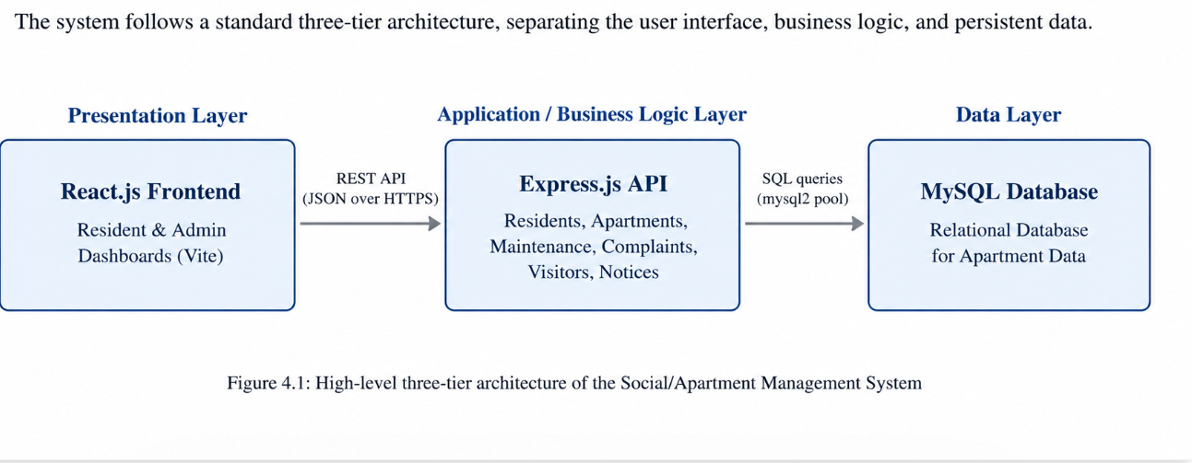

Description of Each Layer
The Presentation Layer is the frontend part of the Social/Apartment Management System, developed using React.js and Vite. It provides the interface through which residents and administrators interact with the application. Residents can access available services and information, while administrators can manage the system through their dashboard. The frontend communicates with the backend through REST API requests and does not directly communicate with the MySQL database.
The Application or Business Logic Layer is implemented using Node.js and Express.js. It acts as an intermediate layer between the frontend and the database. It receives requests from users, verifies authentication and authorization, validates the information, applies the required business rules, and communicates with the database. The backend is organized into routes, controllers, and models, which makes the application easier to understand, maintain, and modify.
The Data Layer consists of the MySQL database, which is responsible for storing and managing the application's persistent data. The database maintains the information required by the system, while the backend communicates with MySQL using the mysql2 driver and a connection pool. This allows multiple requests to be handled efficiently without requiring a separate permanent database connection for every request.

Deployment Architecture

For deployment, the application is configured to run locally for development and demonstration. The Express.js backend runs on port 5000, the Vite development server for the React frontend runs on port 5173, and MySQL runs on its default port 3306. The Vite development proxy forwards API requests from the frontend to the backend. The current project does not include containerization or a CI/CD pipeline, while deployment to a hosted or cloud environment is considered a future enhancement.

CHAPTER 5: DESIGN

Database Design Principles

The database of the system is designed using relational database principles to store and manage the required information in an organized manner. The database is normalized to reduce unnecessary duplication of data and improve consistency. Primary keys are used to uniquely identify records, while foreign keys are used to establish relationships between different tables. UNIQUE constraints help prevent duplicate values, and CHECK constraints ensure that only valid data is entered into the database. For example, the constraints can prevent negative room capacity and ensure that an event's start time occurs before its end time.

ER Diagram / Database Schema
The database consists of seven related tables, shown in Figure 5.1.
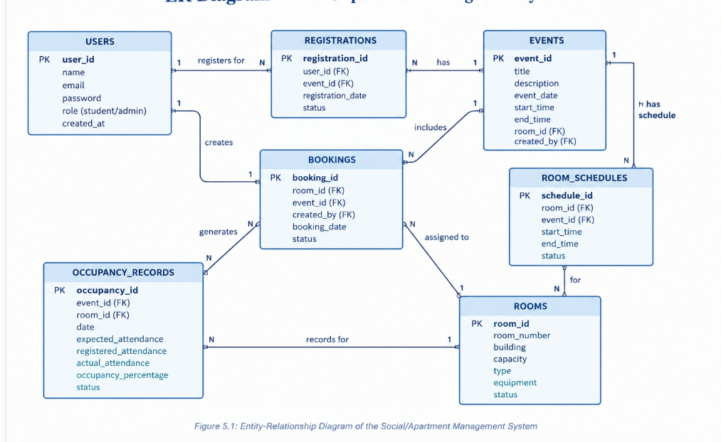
The USERS table stores information about the users of the system, including student and administrator accounts, passwords, and user roles. The ROOMS table stores information about rooms, such as room name, room number, building, capacity, type, equipment, and status. The EVENTS table stores information about events and their assigned rooms. The REGISTRATIONS table establishes the relationship between users and events and prevents the same student from registering for the same event more than once. The ROOM_SCHEDULES table stores the schedules of rooms and events and is used as the main source for checking room availability and scheduling conflicts. The BOOKINGS table stores information about room assignments and the person who made the assignment, providing an audit trail of booking activities. The OCCUPANCY_RECORDS table stores information such as expected attendance, registered attendance, actual attendance, event, room, and date. Together, these tables provide the required database structure for managing the different activities of the system

Design Decisions and Assumptions

- The database is designed using a relational structure in which each table represents a specific type of information. Primary keys are used to uniquely identify records, while foreign keys establish relationships between related tables. UNIQUE constraints are used wherever duplicate records should not be allowed, and CHECK constraints are used to prevent invalid values. The database is also normalized to reduce unnecessary duplication and maintain consistency between related records.
- One important data decision is that ROOM_SCHEDULES is treated as the main source of information for checking room availability and detecting scheduling conflicts. The BOOKINGS table is maintained separately as an audit record that stores information about room assignments and booking activities. Both records are updated together using a database transaction so that the schedule and booking information remain consistent.
- Another important decision is related to event registration capacity. The system does not maintain a separate maximum-participant value for each event. Instead, after a room is assigned to an event, the capacity of that room is treated as the registration limit for the event. This ensures that the number of registrations does not exceed the available capacity of the assigned room.
- The system assumes that each user has a valid account and an assigned role, such as student or administrator. Administrator accounts are responsible for managing rooms, events, bookings, and occupancy information, while students mainly use the system to view events and register for them. The system also assumes that room information, including capacity and status, is correctly maintained by authorized users.
- The system assumes that the room schedule information is accurate and that the start and end times entered for events are valid. The database applies validation rules to ensure that invalid values, such as negative room capacity or an event ending before it starts, are not stored.
- The system also assumes that actual occupancy is entered by an administrator after an event. The current implementation does not automatically collect attendance through QR codes, sensors, or automatic check-in. Therefore, the accuracy of occupancy records depends on the information entered by the administrator.

CHAPTER 6: IMPLEMENTATION

Module-wise Implementation
- The backend implementation of the system is divided into six major modules: Authentication, Rooms, Events, Registrations, Bookings, and Occupancy. Each module is responsible for a specific function of the application. This modular approach separates different responsibilities and makes the system easier to develop, test, maintain, and extend. The modules work together through the Express.js REST API and the MySQL database.
- The Authentication Module manages user registration, login, and protected access to the system. It verifies user credentials and provides authentication information required to access protected resources. Passwords are securely handled using bcrypt, while JSON Web Tokens are used to maintain authenticated sessions. This module also works with role-based authorization to distinguish between student and administrator users.
- The Rooms Module manages room information and availability. Administrators can add, view, update, and delete rooms. When a room is assigned to an event, the system checks whether the room exists, whether it is active, whether its capacity is sufficient, and whether it is already scheduled for another event during the requested period. The room is assigned only when these required conditions are satisfied.
- The Events Module manages the creation and modification of events. Administrators can create events, edit event details, delete events, and assign rooms to events. The system maintains the relationship between an event and its assigned room. The capacity of the assigned room is used as the registration limit for the event, helping prevent the number of registrations from exceeding the available room capacity.
- The Registrations Module allows students to register for events. Before accepting a registration, the system checks whether the student has already registered for the event and whether the event has reached the capacity of its assigned room. This prevents duplicate registrations and prevents registrations from exceeding the available capacity.
- The Bookings Module manages room-booking information and maintains an audit record of booking activities. The ROOM_SCHEDULES table is treated as the main source for checking room availability and scheduling conflicts, while the BOOKINGS table stores information about booking activities. Both records are updated together using a database transaction to maintain consistency.
- The Occupancy Module manages information about room occupancy during events. It stores information such as expected attendance, registered attendance, actual attendance, room, event, and date. The system calculates occupancy percentage using actual attendance and room capacity and categorizes the result as Normal, High, Near Capacity, or Over Capacity.

Front-end Logic
The frontend of the system is developed using React.js and Vite. It provides the interface through which students and administrators interact with the application. React Context API is used to maintain shared application information, including the authenticated user's details and notification messages. This allows commonly required information to be accessed by different components without unnecessarily passing it through multiple levels of the application. The frontend also uses reusable components to provide a consistent user interface. Components such as modals, confirmation dialogs, status badges, loading messages, empty-state messages, and error messages are reused throughout the application. This reduces repeated code and makes the frontend easier to maintain and modify.The frontend provides different functionality depending on the role.

API Integration
The frontend communicates with the backend using REST APIs. Axios is used as the HTTP client for sending requests from the React application to the Express.js backend. Different service files are used for resources such as rooms, events, registrations, bookings, and occupancy, which keeps API communication organized and separates the frontend logic from the individual API operations. The application also handles unauthorized requests. If the backend returns a 401 Unauthorized response, the frontend automatically logs the user out. This ensures that an expired or invalid authentication session does not continue to provide access to protected parts of the application.

Authentication and Authorization

The system uses bcrypt and JSON Web Tokens (JWT) to provide authentication and security. User passwords are protected using bcrypt with 10 salt rounds, meaning that passwords are not stored directly as plain text. During login, the provided credentials are verified and a JWT is generated containing information such as the user's ID, role, and name. The token is then used to identify the authenticated user when accessing protected resources.

CHAPTER 7: FEATURES

List of Main Features
Student-facing features:
- Browse, search, and filter upcoming events.
- View complete event details, including assigned room and capacity.
- Register for events with duplicate-registration and capacity limits.
- View “My Registrations” and registration status.
- Check room availability for a selected date and time.
- View and manage personal profile.
Administrator-facing features:
- Add, edit, and delete rooms.
- Manage room capacity, type, equipment, and status.
- Add, edit, and delete events and assign rooms.
- View a live dashboard with rooms, events, registrations, and occupancy.
- View and manage all bookings, including cancellations.
- View and filter student registrations.
- Record and update room occupancy after an event.
- Automatically calculate occupancy percentage and status.
How Each Feature Works
Room availability checking: given a date, a start time, an end time, and an optional minimum capacity, the system checks every room's status (excluding Maintenance/Inactive rooms), its capacity, and whether any existing room_schedules entry overlaps the requested window, returning two lists — rooms that are available, and rooms that are not, each with a plain-English reason such as “Already booked for ‘AI Workshop’ from 10:00 AM to 12:00 PM.”

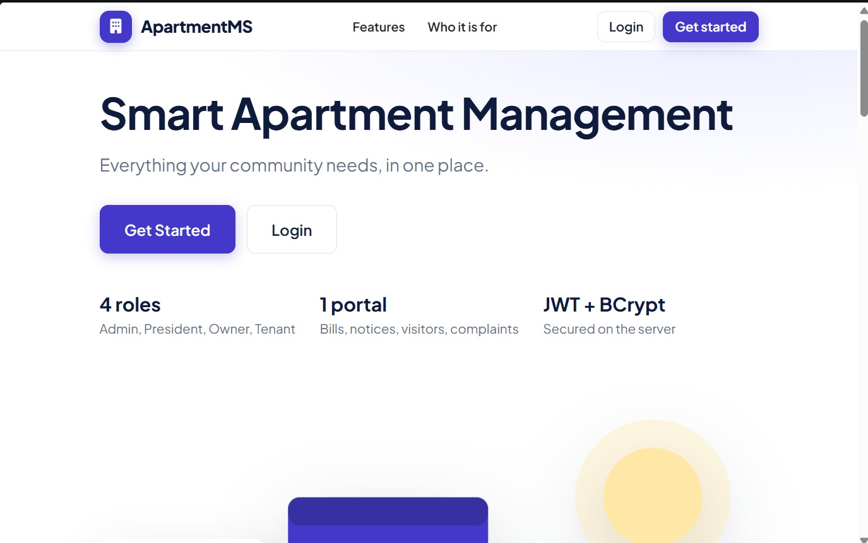
Occupancy percentage calculation: once an admin records the actual headcount for an event, the system computes (actual_occupancy ÷ room_capacity) × 100 and buckets the result into one of

four labels: below 60% is “Normal,” 60–89% is “High,” 90–99% is “Near Capacity,” and 100% or above is “Over Capacity” — shown to the admin as a colored progress bar.
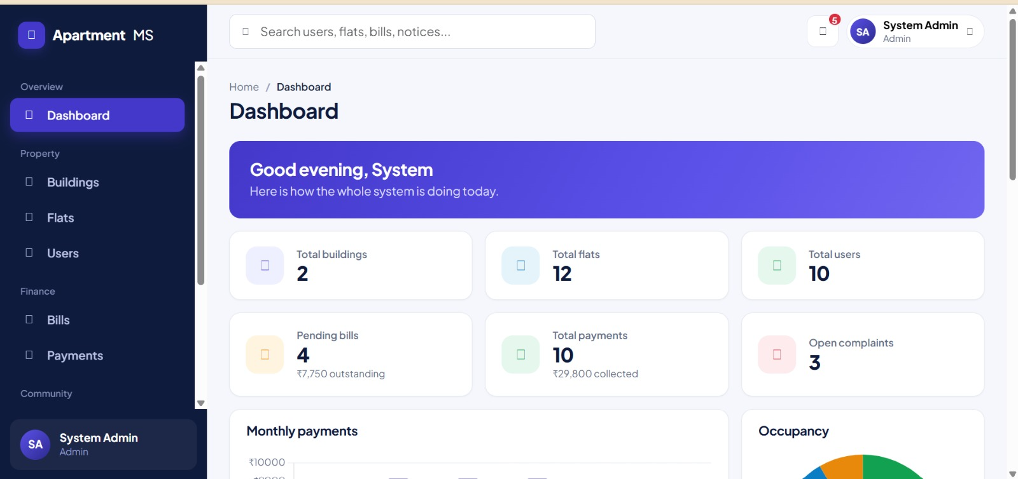
Capacity-reduction warning: if an admin tries to reduce a room's capacity below what an upcoming event assigned to that room expects, the system does not silently allow it — it responds with the specific list of affected events and asks the admin to explicitly confirm before the change is applied.
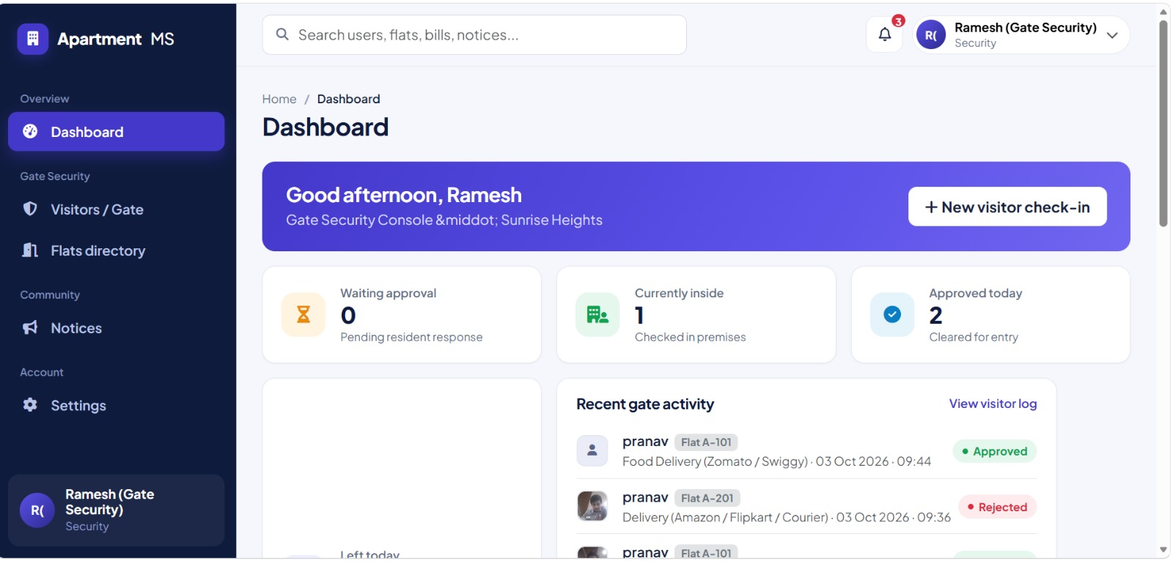
–

CHAPTER 8: TESTING

Postman API Testing
A complete Postman collection was used to test the 22 REST API endpoints of the system. The endpoints were organized into different modules, including Authentication, Rooms, Events, Registrations, Bookings, and Occupancy, along with a health-check endpoint. Login requests were tested to generate the JWT token, which was then used for accessing protected APIs. Important workflows such as creating events, assigning rooms, registering students, creating bookings, and recording occupancy were tested to verify that the APIs work correctly.

Integration Testing
The system was tested end-to-end with a real MySQL database to verify the integration between the React frontend, Express backend, and database. Each module was tested with actual database operations to ensure that data was correctly inserted, updated, retrieved, and deleted. The complete database was also rebuilt using the provided schema and seed files, after which the major system functions were tested again to confirm that the application works correctly from a fresh installation.

Tools Used for Testing
• Postman — REST API and endpoint testing
• curl — Command-line API testing
• MySQL Command-Line Client — Database and constraint verification
• MySQL Workbench — Database structure and data verification
• Manual Browser Testing — Testing React frontend functionality and user interface
• VS Code — Debugging and development testing

Test Cases and Results
A representative sample of the test cases executed, drawn from the project's actual test log, is summarized below.

# | Test Case | Expected Result | Actual Result
1 | Login with wrong password | 401, login rejected | Pass
2 | Student token calls an admin-only route | 403 Forbidden | Pass
3 | Register for the same event twice | Second attempt returns 409 Conflict | Pass
4 | Assign a Maintenance-status room to an event | 409, room status rejected | Pass
5 | Assign a room smaller than expected participants | 409, capacity message with exact numbers | Pass
6 | Assign a room already booked for an overlapping time | 409, conflict message naming the clashing event | Pass
7 | Request a room for a slot starting exactly when another ends | No conflict (back-to-back allowed) | Pass

# | Test Case | Expected Result | Actual Result
8 | Create a room with negative capacity | 400, rejected before reaching the database | Pass
9 | Create a room with a duplicate room number + building | 409, friendly duplicate message (no raw SQL error) | Pass
10 | Reduce a room's capacity below an upcoming event's needs | 409 warning listing the affected event(s) | Pass
11 | Delete a room with existing booking history | Room marked Inactive instead of deleted | Pass
12 | Delete an event with registrations and a room assignment | Cascades cleanly; zero orphaned rows afterward | Pass
13 | Create an occupancy record with a negative headcount | 400, rejected | Pass
14 | Occupancy percentage at 45% / 95% / 108% | Labeled Normal / Near Capacity / Over Capacity | Pass
One test also uncovered a real defect rather than confirming correct behavior: pre-filling the Edit Event form's date/time fields initially used the API's raw UTC-encoded timestamp instead of converting it to the browser's local time, which would have shown an incorrect time (for example, 4:30 AM instead of 10:00 AM) on any machine not running in the UTC timezone. This is discussed further in Chapter 10.

CHAPTER 9: DEPLOYMENT

Steps to Deploy
- Initialize the MySQL database using schema.sql.
- Insert sample data using seed.sql.
- Start the backend using Node.js and Express.
- Backend runs on port 5000.
- Start the React frontend using Vite.
- Frontend runs on port 5173.
- Open the application in a web browser and log in.

Environment Configuration
- Configure MySQL host, port, username, password, and database name.
- Configure JWT secret and token expiry.
- Configure backend server port.
- Configure frontend URL for CORS.
- Store configuration details in the .env file.
- Keep. env private and exclude it from GitHub.
- Use .env.example with placeholder values.

Hosting of Frontend and Backend
For the project demonstration, the React frontend, Node.js/Express backend, and MySQL database are hosted locally on the development computer. The frontend runs on port 5173, the backend runs on port 5000, and MySQL uses port 3306. This local deployment is suitable for development, testing, and classroom demonstration. A cloud-based production deployment is not included in the current implementation.

CHAPTER 10: CHALLENGES & LIMITATIONS

Issues Faced During Development
- Room Schedule and Booking Management: Managing room schedules and bookings required careful synchronization to avoid conflicts and duplicate room assignments.
- Date and Time Handling: Issues were encountered while handling event date and time values between the frontend, backend, and database.
- Database Connection Issues: MySQL connection and startup issues occurred during development and required troubleshooting.
- Room Capacity Validation: Additional validation was required to ensure that events were not assigned to rooms with insufficient capacity.
- Role-Based Access: Proper access restrictions were required to prevent students from accessing administrator functions.

Solutions Applied
The room schedule and booking issue was resolved by using ROOM_SCHEDULES as the main source for checking room conflicts, while BOOKINGS is maintained for tracking and audit purposes. Date and time handling was improved by using a common date and time utility to correctly convert and display event timings. MySQL connection and startup issues were resolved by correcting the database configuration and restarting the MySQL service when required. Room capacity validation was implemented to ensure that events are assigned only to suitable rooms and registrations do not exceed the available capacity. Role-based authorization using JWT authentication and middleware was also implemented to ensure that only authorized administrators can access administrative functions.

Current Limitations or Known Bugs
- No Email Verification: The system does not currently provide email verification for user accounts.
- No Password Reset: A password recovery or reset feature is not currently implemented.
- Manual Occupancy Entry: Actual room occupancy must be entered manually by an administrator.
- No QR Check-in: Automatic attendance or occupancy tracking through QR codes is not available.
- Local Deployment: The current system is designed and tested on a local environment and has not been deployed to a public cloud server.

CHAPTER 11: FUTURE ENHANCEMENTS

Planned Features
- Email Verification and Password Reset: Add email verification during registration and provide a secure password-reset option for users.
- Admin Management: Provide a secure interface for creating and managing administrator accounts.
- Calendar View: Add a calendar interface to display room bookings and event schedules clearly.
- Notifications: Send email or SMS notifications for event registrations, confirmations, and reminders.
- QR-Code Check-in: Introduce QR-code-based check-in to automatically record event attendance and occupancy.
- Mobile Application: Develop a mobile application to provide convenient access to events, rooms, registrations, and notifications.

Possible Integrations or Optimizations
- Calendar Integration: Integrate a calendar library such as FullCalendar for better room and event schedule management.
- Availability Optimization: Use caching for frequently requested room-availability information to improve response time.
- Cloud Deployment: Deploy the application using cloud platforms for remote access and scalability.
- Docker Integration: Containerize the frontend, backend, and database environment for consistent deployment.
- Automated Testing: Add automated testing using tools such as Jest and Supertest to detect errors and prevent future regressions.

CHAPTER 12: CONCLUSION

Summary of the Project
This project was developed to provide a centralized web-based system for managing rooms, events, bookings, student registrations, and occupancy. The system uses a React.js frontend, Node.js and Express.js backend, and MySQL database. It provides separate features for students and administrators and helps reduce manual work, scheduling conflicts, duplicate registrations, and room capacity issues.

What Was Achieved
The completed system provides secure user authentication, room and event management, room availability checking, event registration, booking management, and occupancy tracking. It prevents duplicate registrations and double-booking of rooms and checks room capacity before assigning events. Administrators can manage rooms, events, bookings, registrations, and occupancy through the dashboard, while students can browse events, check room availability, and register for events. The system was also tested using Postman, curl, MySQL, and manual browser testing to verify its major functions.

Skills Learned
Working on this project provided practical knowledge of React.js frontend development, Node.js and Express.js backend development, MySQL database design, REST API development, authentication and authorization, and database operations. The project also helped in understanding how to connect frontend, backend, and database components into a complete application. Additional skills were gained in API testing, debugging, room scheduling, capacity validation, role-based access control, and systematic testing of different system functions.

CHAPTER 13: REFERENCES
    - React — Official Documentation, https://react.dev
    - Vite — Official Documentation, https://vitejs.dev
    - Node.js — Official Documentation, https://nodejs.org/en/docs
    - Express.js — Official Documentation, https://expressjs.com
    - MySQL 8.0 Reference Manual, https://dev.mysql.com/doc/refman/8.0/en/
    - mysql2 (Node.js MySQL driver) — npm documentation, https://www.npmjs.com/package/mysql2
    - jsonwebtoken — npm documentation, https://www.npmjs.com/package/jsonwebtoken
    - bcrypt — npm documentation, https://www.npmjs.com/package/bcrypt
    - Postman Learning Center, https://learning.postman.com
    - MDN Web Docs — JavaScript and Web APIs reference, https://developer.mozilla.org

CHAPTER 14: APPENDICES

Appendix A: Sample Code Snippet
The core room-conflict overlap query, used consistently across the system:
// The single overlap rule used everywhere a room's schedule is checked
// (room availability search, event room-assignment, booking creation): SELECT rs.room_id, rs.start_time, rs.end_time, e.event_name
FROM room_schedules rs
JOIN events e ON rs.event_id = e.event_id WHERE rs.status = 'Scheduled'
AND rs.start_time < ? -- requested end time AND rs.end_time > ?; -- requested start time

Appendix B: Installation and Setup Instructions
- mysql -u root -p < database/schema.sql
- mysql -u root -p < database/seed.sql
- cd server && npm install && npm run dev (backend, port 5000)
- cd client && npm install && npm run dev (frontend, port 5173)
- Open http://localhost:5173 in a browser

Appendix C: Default Login Credentials
All seeded accounts use the password “password123”.

Role | Email
Admin | admin@aprtment.mail
President | priyanka.k@president.mail
Tenant | geya.reddy@ .mail college.edu
Security | rahul.verma@college.edu,ananya.rao@college.edu, kiran.kumar@college.edu, sneha.patil@college.edu

Appendix D: API Reference Summary
22 endpoints across six resources; full request/response examples are in the accompanying Postman collection.

Resource | Endpoints
Auth | POST /register, POST /login, GET /me
Rooms | GET /, GET /:id, GET /available, POST /, PUT /:id, DELETE /:id
Events | GET /, GET /:id, POST /, PUT /:id, DELETE /:id, PUT /:id/assign-room
Registrations | POST /, GET /my, GET /event/:eventId, GET /
Bookings | GET /, POST /, PUT /:id, DELETE /:id
Occupancy | GET /, POST /, PUT /:id

Appendix E: Screenshots
The following pages are left for the student to complete with actual screenshots taken from the running application before submission. Suggested screenshots, in order:
- Login Page
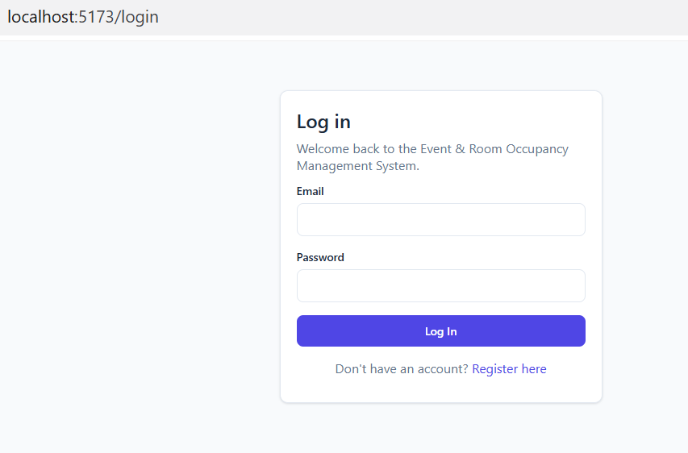
- Student Dashboard
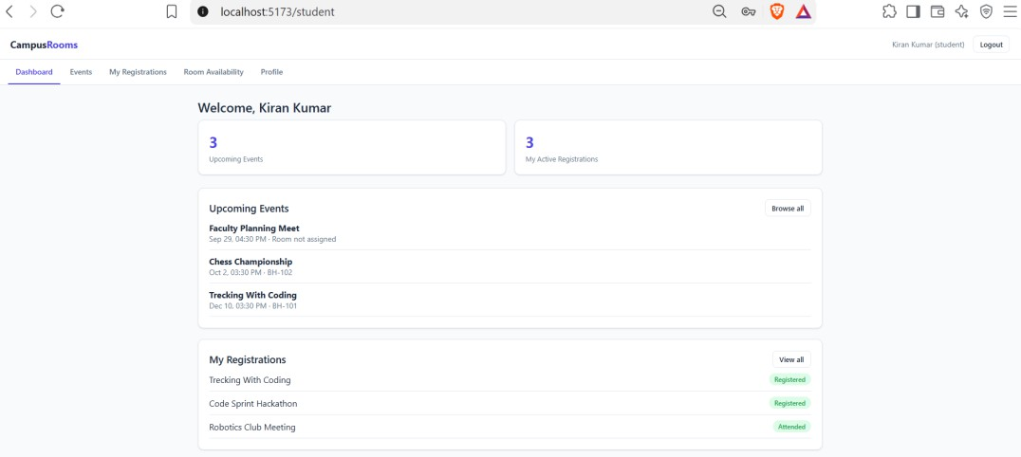
- Events Page (student’s view)
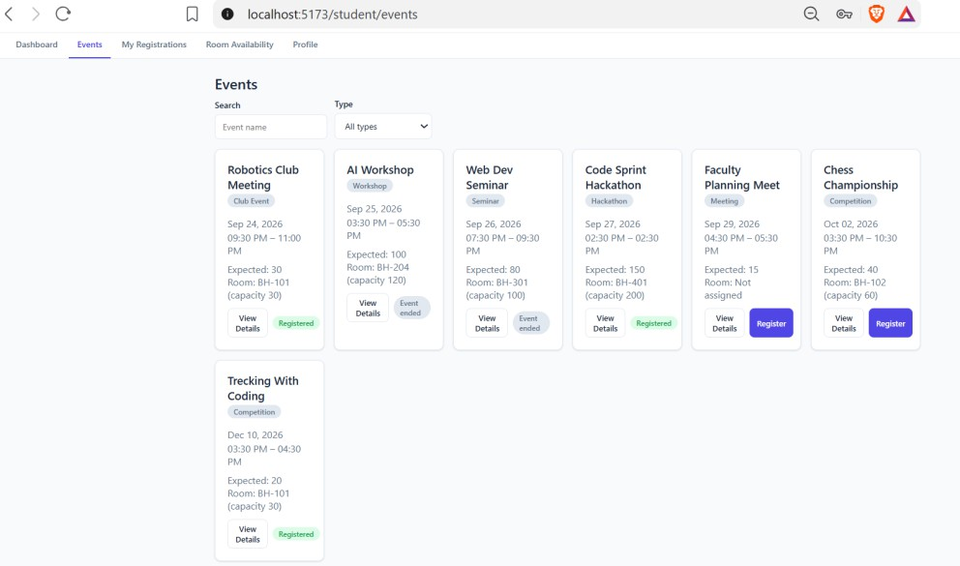

- Room Availability Page
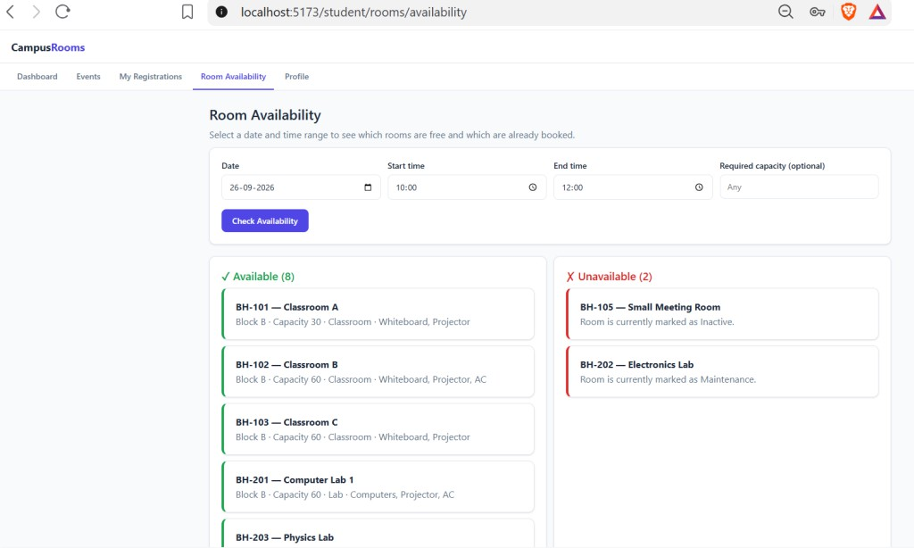
- Admin Dashboard
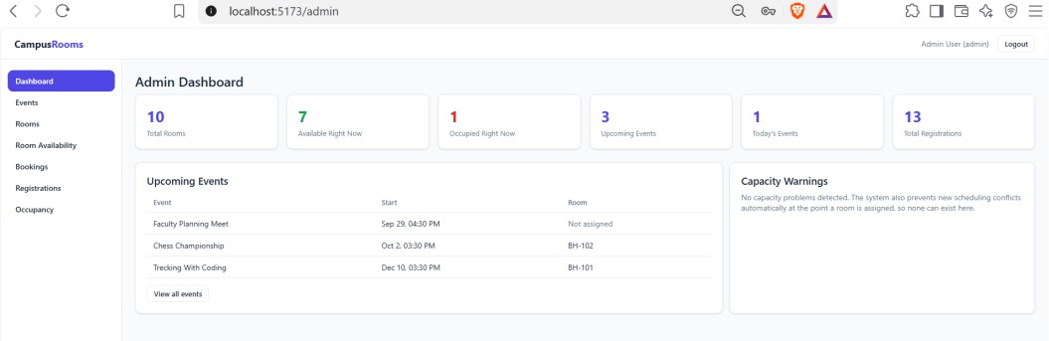
- Manage Rooms page, including the Add/Edit Room modal
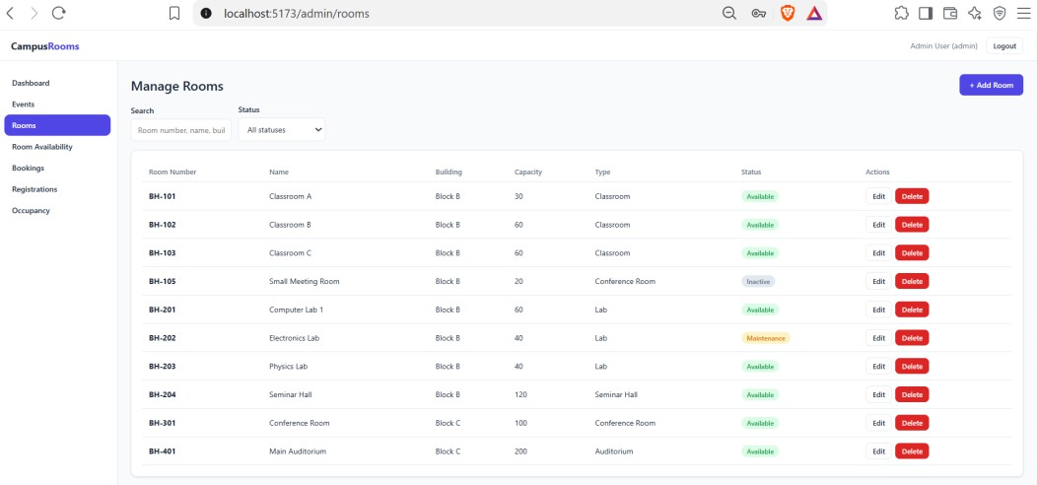

- Manage Events page, including the Assign Room modal
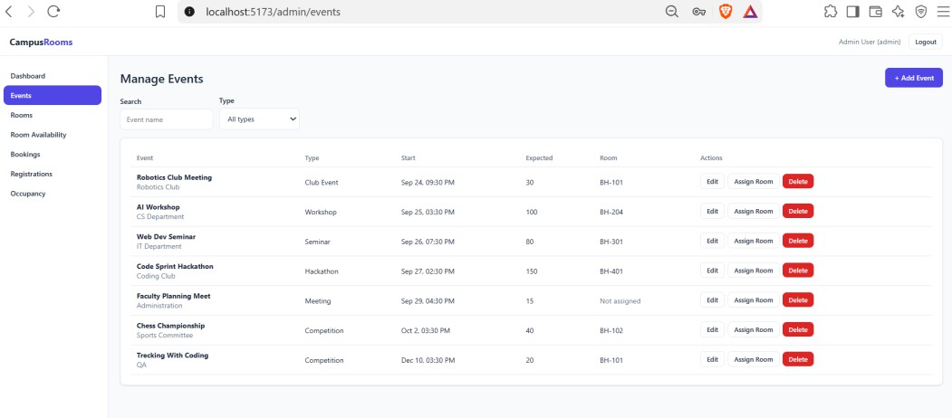
- Manage Occupancy page, showing the colored percentage bar
